CLPS Student Dress Code
Girls’ Uniform

Tops
(Tucked in for K-6)
Long Sleeve or Short Sleeve
- White Turtleneck
- White Button Down
- Hunter Green Polo
- Navy Blue Polo
- White Polo
- White Middy (may be untucked)
Bottoms
- Plaid Jumper, Skirt or Skort (A-line design)
  - Must reach mid-knee
  - Modesty Shorts (under all skirts)-OR-
  - Navy, Black or White Leggings

- Navy Jumper, Skirt or Skort (A-line design)
  - Must reach mid-knee
  - Modesty Shorts (under all skirts)-OR-
  - Navy, Black or White Leggings

- Navy Pants or Capris (no skinny-style bottoms)
  - No denim

Shoes (closed-toe)
- Predominantly Black or White Tennis Shoes (K-6)
- Black or Brown Mary Janes (Max heel 1 inch)
- Black or Brown Boots (Max heel 1 inch)
- White, navy or black socks or tights only

Outerwear
- Sweatshirts
- Hoodies
- Sweaters
- Jackets
- Cardigans
Color options:
- Hunter Green
- Navy
- Black
- White
- Gray
Must be worn over regular uniform collared shirt
Must be solid (no stripes, patterns, spots, plaids, etc)
No Logos (except CLPS logo)
Accessories
- Hair bows and headbands should be in school colors
- Students may wear modest jewelry.
- Students may not add extra accessories to uniform such as scarves, wraps, suspenders, etc.)
- Hats, beanies or other head coverings are not allowed at any time
- Plaid ties are optional

Other Notes:
- K-6 girls may wear solid white shirt under uniform shirt
- 7-12 girls may wear any color undershirt
- 7-12 girls may wear any color, closed-toe shoe with heel under 1 inch
- No tattoos
- Clothes should not be torn or have holes
- Girls may not wear khaki
- Coats may be worn to school but cannot be worn in class, lunch or hallways unless they meet the outerwear guidelines.

Free Dress Day for Girls:
- Modesty is expected
- Clothing must reach mid-knee
- No tight-fitting skinny jeans (please use discernment)
- Leggings may not be worn as pants
- Closed toed shoes only
- No shoes with heel over 1 inch
- No hats or beanies
- No sleeveless shirts
- No transparent clothing
- No clothing with inappropriate emblem, insignia, wording or picture

Where can I purchase items?
You may purchase uniform clothes many different places. The store below is our primary source:
Lands’ End School
www. landsend.com/school
Preferred School Number 900141805

Updated July, 2015: The purpose of the CLPS dress code is to present a positive image, minimize distraction, and provide an environment conducive to learning. All students are expected to maintain good grooming habits and appropriate dress. Students in violation of the dress code will be sent to the office, and a parent will be called to bring appropriate clothing to their child. If you see someone wearing something, do not assume it is in dress code. Students can be addressed about dress code at any time of the day. Students must wear CLPS uniform while attending any school activity unless otherwise notified.

CLPS Girls Dress Code

Shirts
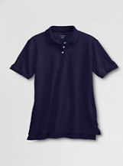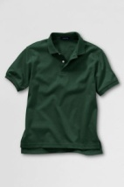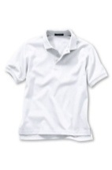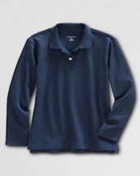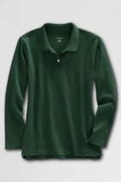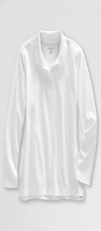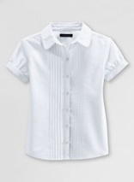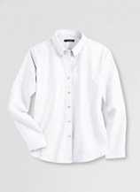
Navy, green, or white polos allowed – short sleeve or long sleeve. White, collared, buttoned shirts are allowed.

Jumpers, Skirts, Pants & Capris Physical Education
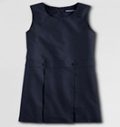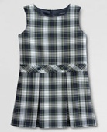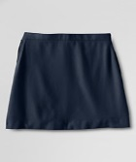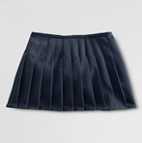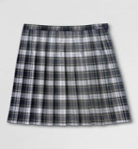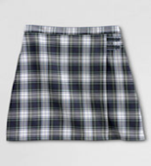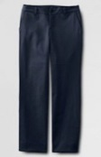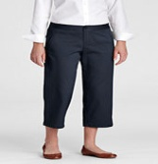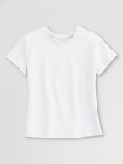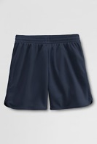
“White plaid” pattern or navy skirts and jumpers must reach mid-knee when standing; modesty shorts are required under skirts.

Sweaters & Hoodies
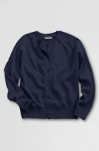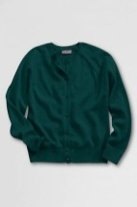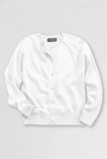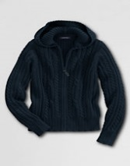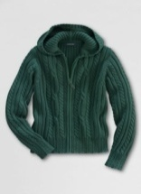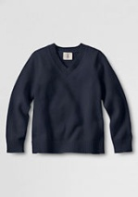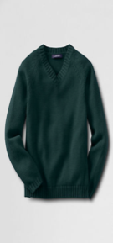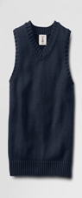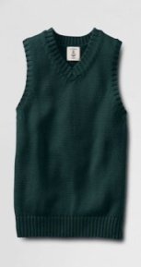
Students must wear a collared, uniform-approved shirt with sweaters or hoodies.
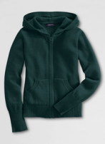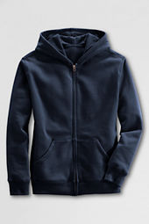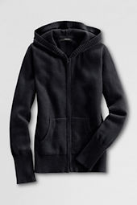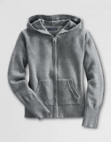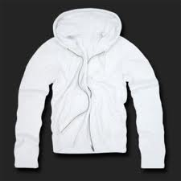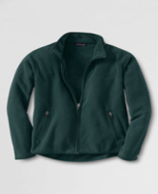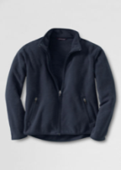
Hoodies may be pullover or zipper style. They must be solid navy, green, white, black, or gray; no patterns or logos other than a CLPS logo are allowed. Outerwear that is out of dress code may not be worn during class but may be stored in a backpack or hallway until the end of the day.

K-6th Grade Girls Shoe Dress Code
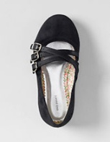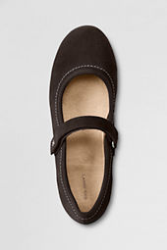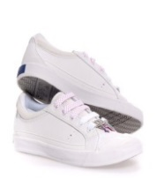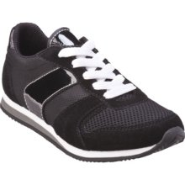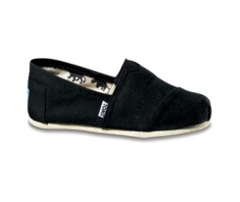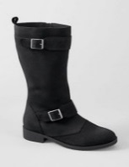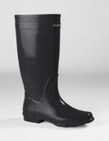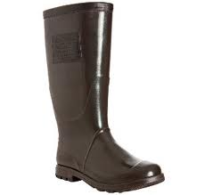
Dark dress shoes with a maximum heel height of 1 inch or predominantly black or white tennis shoes are allowed. Black or brown boots allowed for weather. Socks or tights must be white, navy or black.

7th – 12th Grade Girls Shoe Dress Code
Any closed-toe shoe with a maximum heel height of 1 inch is allowed. Socks or tights must be white, navy or black.

CLPS Student Dress Code
Boys’ Uniform

Tops
(Tucked in for K-6)
Long Sleeve or Short Sleeve
- White Button Down
- Hunter Green Polo
- Navy Blue Polo
- White Polo

Bottoms
- Khaki Pants or Khaki Shorts
  - No cargo style (outside pockets)

- Navy Pants or Shorts
  - No cargo style (outside pockets
  - No denim

Shoes (closed-toe)
- Predominantly Black or White Tennis Shoes (K-6)
- Black or Brown Dress Shoes
- Black or Brown Boots
- White, Brown or Black Socks

Outerwear
- Sweatshirts
- Hoodies
- Sweaters
- Jackets
- Cardigans

Color options:
- Hunter Green
- Navy
- Black
- White
- Gray
Must be worn over regular uniform collared shirt
Must be solid (no stripes, patterns, spots, plaids, etc)
No Logos (except CLPS logo)

Accessories
- Students may not add extra accessories to uniform such as scarves, wraps, suspenders, etc.)
- Hats, beanies or other head coverings are not allowed at any time
- Plaid ties are optional
- Dark belts are optional

Other Notes:
- K-6 boys may wear solid white shirt under uniform shirt
- 7-12 boys may wear any color undershirt
- 7-12 boys may wear any color, closed-toe shoe
- No tattoos
- Clothes should not be torn or have holes
- Coats may be worn to school but cannot be worn in class, lunch or hallways unless they meet the outerwear guidelines.

Free Dress Day for Boys:
- No tight-fitting clothing
- Closed-toed shoes only
- No hats or beanies
- No sleeveless shirts
- No clothing with inappropriate emblem, insignia, wording or picture

Where can I purchase items?
You may purchase uniform clothes many different places. The store below is our primary source:
Lands’ End School
www. landsend.com/school
Preferred School Number 900141805

Updated July, 2015: The purpose of the CLPS dress code is to present a positive image, minimize distraction, and provide an environment conducive to learning. All students are expected to maintain good grooming habits and appropriate dress. Students in violation of the dress code will be sent to the office, and a parent will be called to bring appropriate clothing to their child. If you see someone wearing something, do not assume it is in dress code. Students can be addressed about dress code at any time of the day. Students must wear CLPS uniform while attending any school activity unless otherwise notified.

CLPS Boys Dress Code

Shirts
- 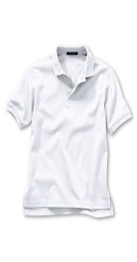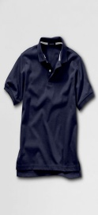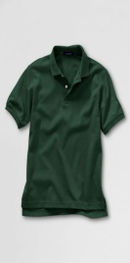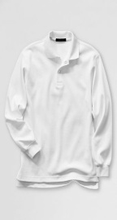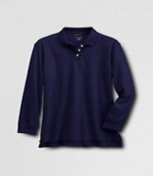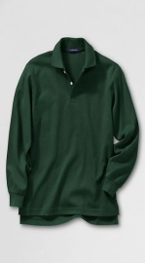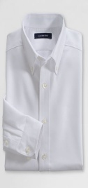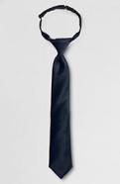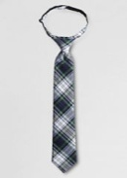
Navy, green, or white polos as well as white, collared, buttoned shirts are allowed –short sleeve or long sleeve.
Plaid ties are optional.

Pants & Shorts Physical Education
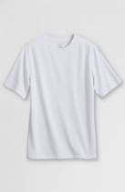
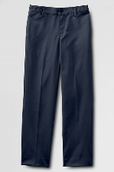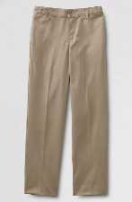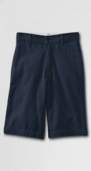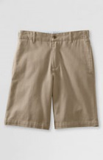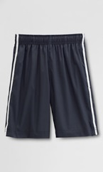
No cargo style shorts allowed.

Sweaters & Hoodies
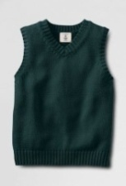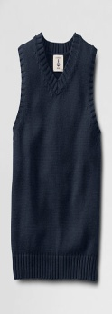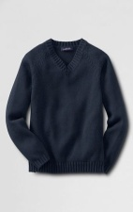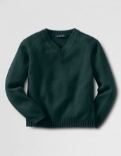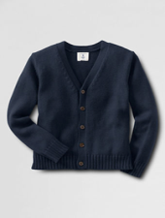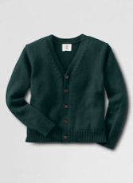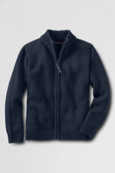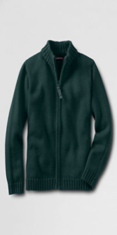
Students must wear a collared, uniform-approved shirt with sweaters or hoodies.
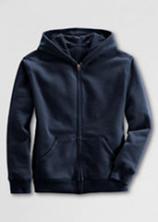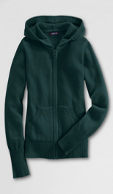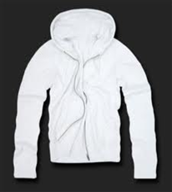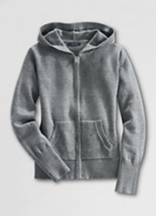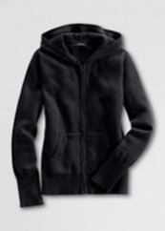

Hoodies may be pullover or zipper style. They must be solid navy, green, white, black or gray; no patterns or logos other than a CLPS logo are allowed. Outerwear that is out of dress code may not be worn during class but may be stored in a backpack or hallway until the end of the day.

K-6 Boys Shoe Dress Code
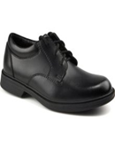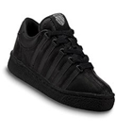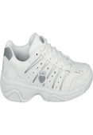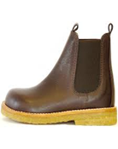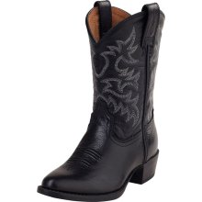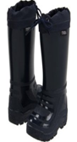
Predominantly black or white tennis shoes or dark dress shoes are allowed. Black or brown boots allowed for weather.

7th – 12th Grade Boys Shoe Dress Code - Any closed-toed shoe is allowed. Socks should be black, white, navy or brown.

